Guide to Setting Up the Database in MySQL
Objective:
The objective of this guide is to provide clear and concise instructions for setting up the TriviaDB database in MySQL, ensuring proper database creation and configuration for managing movies records.

Step 1: Download MySQL

- Visit the official MySQL website: 🔗 MySQL Community Downloads
- Scroll down to "MySQL Community (GPL) Downloads »" and click it.
- Click "MySQL Installer for Windows" (if you're using Windows) or select the appropriate version for your operating system.
- Choose the "Windows (x86, 64-bit), MSI Installer" (recommended for easy installation).
- Click "Download".
Step 2: Install MySQL

- Run the downloaded .msi file.
- Select "Custom" or "Developer Default" setup type (for full installation).
- Ensure that MySQL Server, Workbench, and Shell are selected.
- Click Next and Install.
- During configuration, set:
  - Root password (keep it secure).
  - Optionally, create a new MySQL user.
  - Complete the installation and finish the setup.
Step 3: Creation of the database and collections

Open MySQL Workbench 8.0 CE

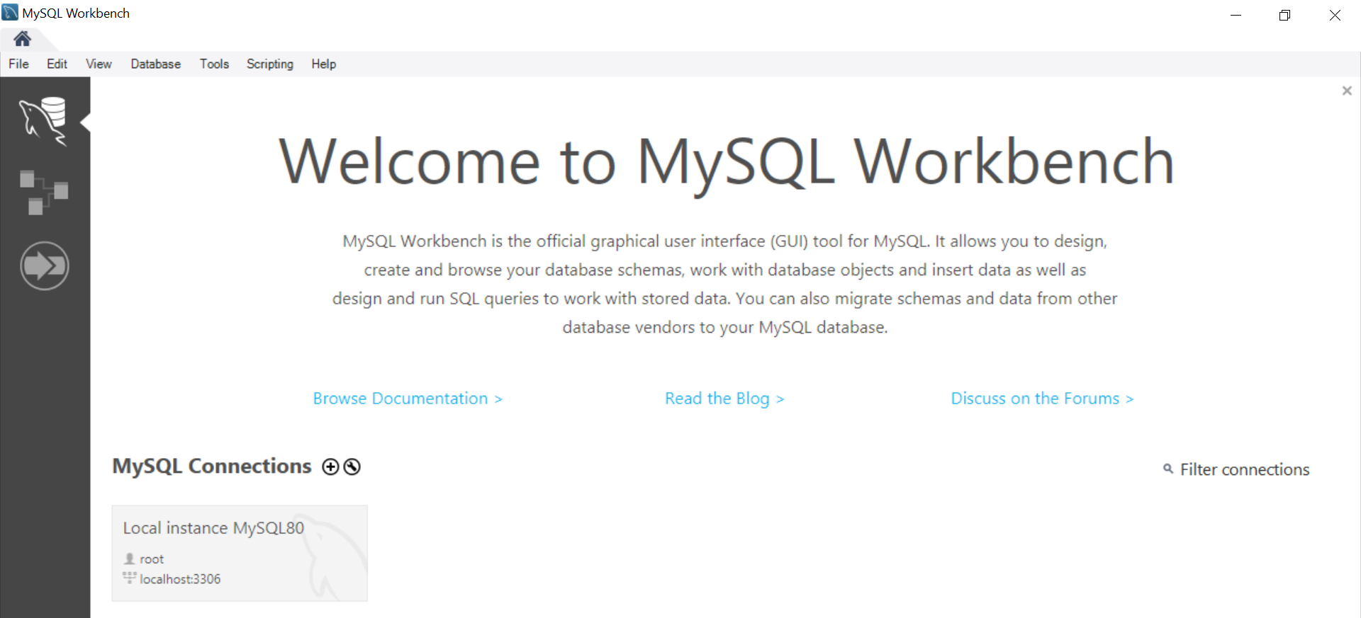
Connect to the local instance with your root password.
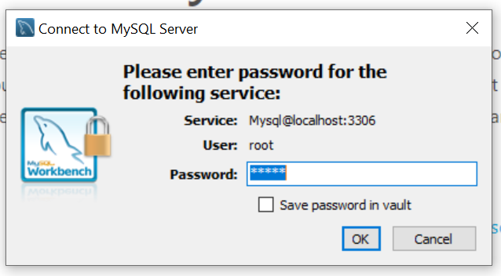

Click on Create New Schema named triviadb to open the following tab:
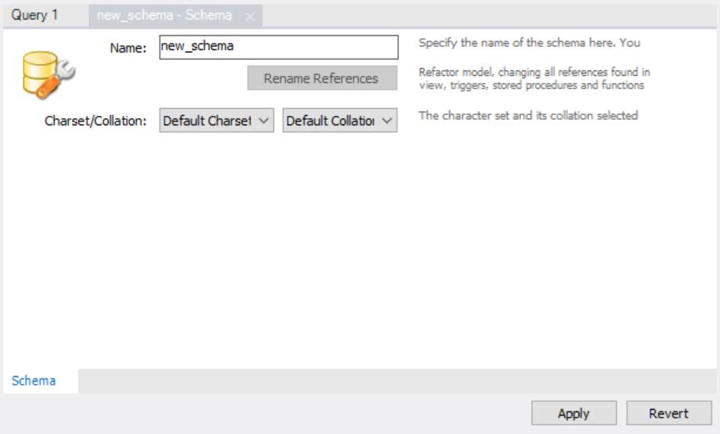
After creating the database, copy and paste the content of the TriviaDB.sql file from the database folder into the SQL tab, then execute it to create all tables.

